**SOLUTION ARCHITECTURE**

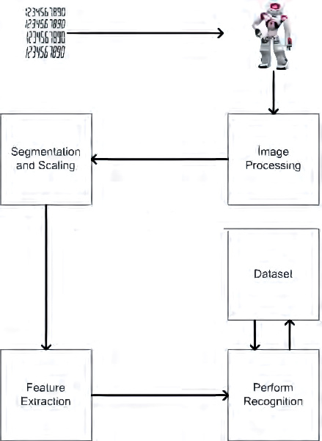

**MNIST dataset processing with python**

